Lab 3
C Language

Task 1:
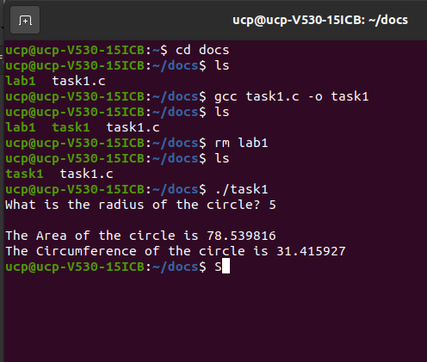

Task 2:
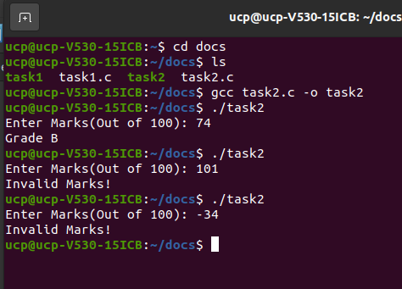

Task 3:
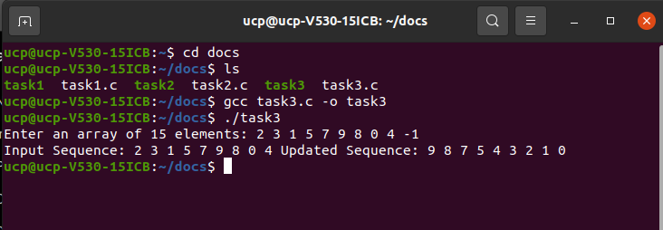
Task 4:

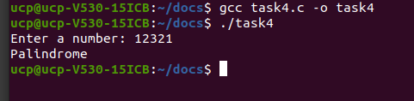

Task 5:
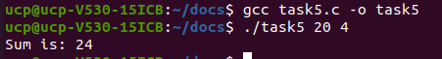

Task 6:
